EE 183DA lab2

Lu Fan, 804668206

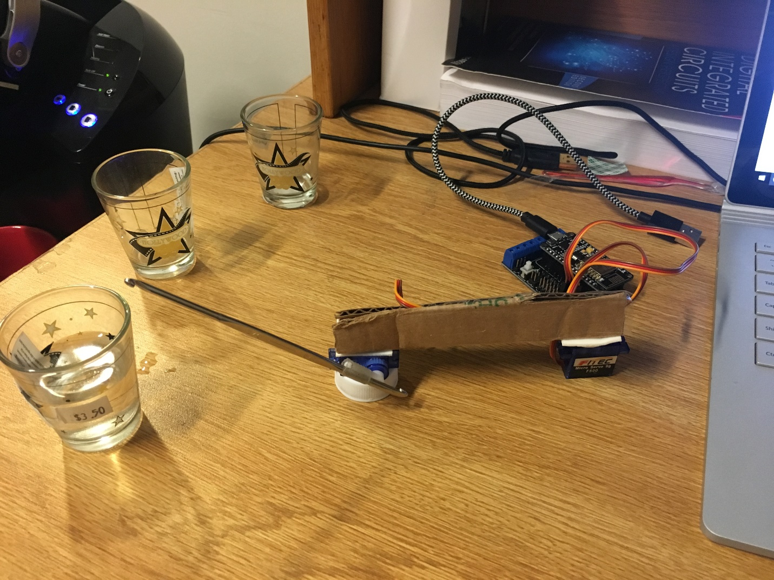

**Object**

In this lab, I am going to build a simple robot that create some patterned noise, since we have two servo motor, it is easy to think of using one control the position of some mechanical structure to move around in a 2-D plane and another motor drive an end-effector to hit different objects to create different sounds. That is the idea of my robot.

**Bill of material**

|  |  |
| --- | --- |
| Parts | number |
| ESP8266-12E microcontroller | 1 |
| ESP12-E motor shield | 1 |
| Servo motor (FS90 and FS90R) | 2 |
| Micro USB cable | 1 |
| Cardboard | some |
| Tape | some |
| Cups with water | 3 |

**Wiring schematic**

Insert ESP8266 board into ESP-12E motor shield properly.

|  |  |
| --- | --- |
| FS90 | Motor shield |
| Signal (orange) | GPIO 4D |
| Power (red) | GPIO 4G |
| Ground (brown) | GPIO 4V |

|  |  |
| --- | --- |
| FS90R | Motor shield |
| Signal (orange) | GPIO 2D |
| Power (red) | GPIO 2G |
| Ground (brown) | GPIO 2V |

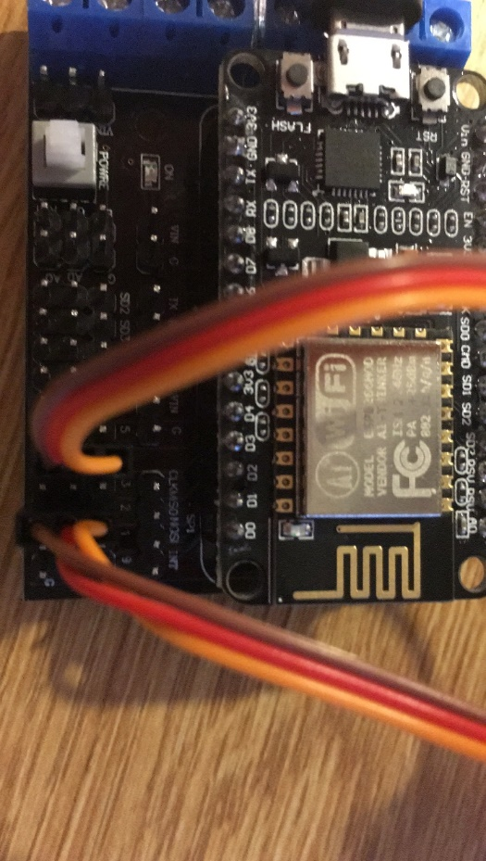

**Mechanical Drawing**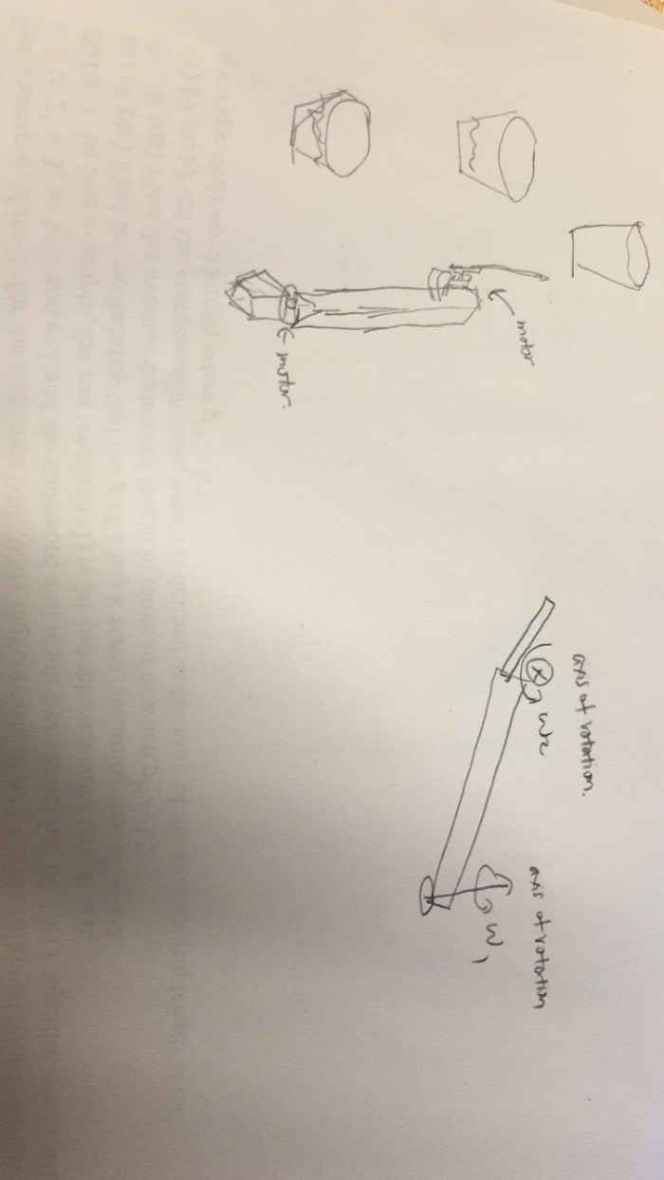

**Description of the robot**

The robot uses one servo motor to control its angular position in a 2D-plane, this motor connects to an arm with connect to another motor that drive another arm to hit the objects.

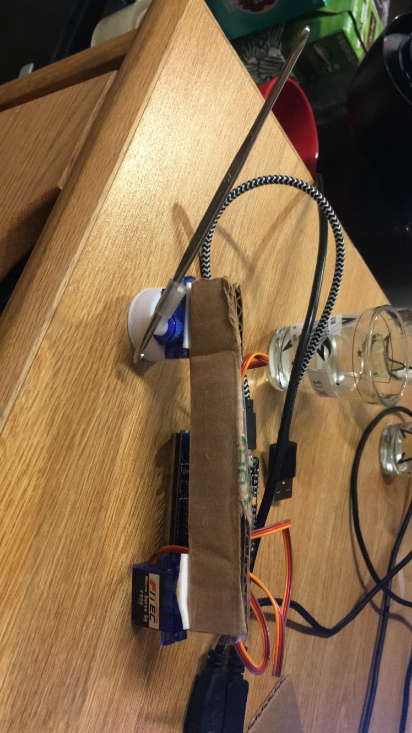

The structure controlled by ESP8266 board using Arduino language. Since the servo motor can measure the angular position of the motor, so it is easy to control the angular position with good accuracy, so I choose to use servo motor to control the position of the arm in the operational plane, the motor I left is a servo type-R motor which is easy to control the velocity of motor rather than angular position. Since hit the cup require less accuracy in terms of position, I can use this motor to drive end-effector to hit the cup, ideally, this motor is better to be another regular servo motor since we want the end-effector go back to original position after each hitting, use servo typr-R motor is hard to make it back where it original positioned. That is showed in demo that sometimes it will miss the hit.

The three glass cup filled different amount of water can create different pitch of sound once been hit. Technically we can use much more than three cups to create better variety of sounds for this project. The more water the cup has, the lower the pitch it creates. The position of the cup can be arbitrary as long as there is enough room for it. Note that the servo motor only rotate 180 degree.

The code for this is mainly a function the take an angle as argument, the function moves the arm to desired angle and hit whatever at that position. The code also creates a web control page for this board to control the arm hits high, mid and low pitch in this project.

It is worth to mentioning that without any input signal the servo-R motor will continue rotating, so we need to give it a signal to stop it from rotating when we need to. In this project, we find servo.writeMicrosecond(1400) will put that motor in rest, that is an experimental value. Technically servo.write(90) will make it stop but during the process it still move at low speed.